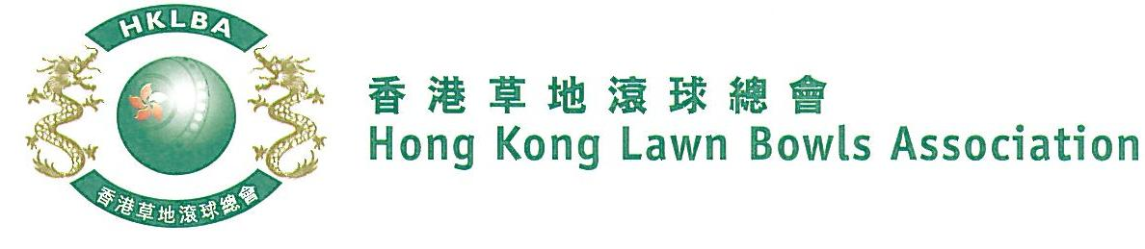
Women’s Knock-out Singles Competition 2019
Sunday, 15th December 2019
Entries Form

The annual Women’s Knock-out Singles Competition is scheduled to be held on Sunday, 15th December 2019. Fall back day is 12th January, 2020.
Prizes will be awarded to the winner, second and joint thirds. Schedule and conditions of play will be issued with the draw.
Entries deadline is Monday, 11th November 2019. Entries fee is $100 per player.
Club convenors are requested to email the duly completed entries form in MS Word doc format to competition@hklba.org before the deadline.

Ref. | Name | Contact Tel. No.
1
2
3
4
5
6
7
8
9
10
11
12
13
14
15

Club : ______________ Convenor's signature: ______________ Date : __________________

