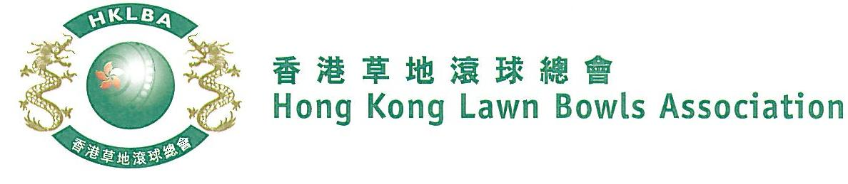
Novice Pairs Competition 2019
Entries Form

Novice Pairs Competition 2019 is scheduled to commence on Thursday, 26th September, 2019. Matches will normally be scheduled for the evening session every Thursday. Finals will be held at the 2019 National Championship Finals Day - Winter.

Format: Three bowls per player, 18 ends. Either indoor or outdoor green is allowed as home green. Prizes will be awarded to the winner, second and joint thirds.

Tentative dates: 26th September, 3rd, 10th, 17th, 24th & 31st October, 7th and 21st November, 2019. Other mid-week evenings may be used. National Championship Finals Day on Sunday, 2nd February 2020. Re-scheduling of the Semi-finals and Finals by competitors’ mutual agreement is not permitted.

Entries deadline is Monday, 9th September, 2019. Entries is $200 per team.

Entries shall be restricted to persons who have not won any open international competition approved by World Bowls or any national competition included in Bye-law 6.1.c.(i) to (xvi).

Women’s Entries
Ref. | Lead | Skip | Contact Tel. No. | Home Green
1
2
3
4
5
6
7
8
9
10
Men’s Entries
Ref. | Lead | Skip | Contact Tel. No. | Home Green
1
2
3
4
5
6
7
8
9
10

Club convenors are requested to email the duly completed entries form in MS Word doc format to competition@hklba.org before the deadline.

Club : ________________ Convenor's Signature: _______________________ Date : _______________

