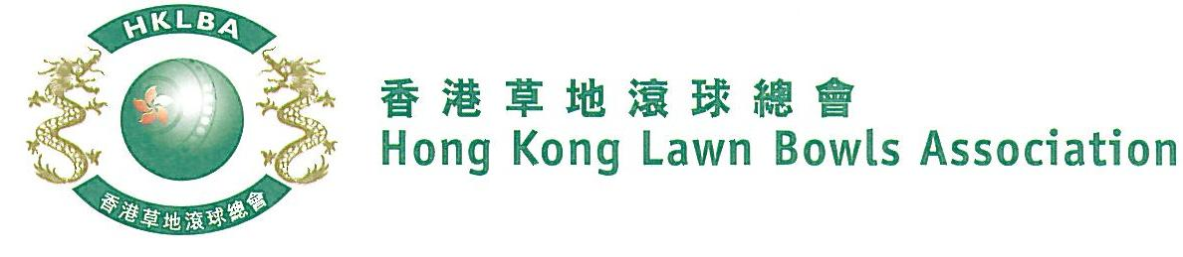
National Pairs Championship 2020
Entries Form
Updated on 16 Jan, 2020
The National Pairs Championship 2020 is scheduled to commence on Sunday, 1st March 2020. Matches in the men’s section will normally be scheduled for the morning session, and women’s section for the afternoon session. The Finals will be held at the 2020 National Championship Finals Day - Summer.

Format: Three bowls per player, 18 ends.

Tentative dates: 1st, 15th, 22nd, 29th March and 12th, 19th April. Other Sundays may be used. National Championship Finals Day on 28th June, 2020. Re-scheduling of the Quarter-finals, Semi-finals and Finals by competitors’ mutual agreement is not permitted.

Entries deadline is Monday, 3rd February 2020. Entries fee is $200 per team. Prizes will be awarded to the winner, second and joint thirds.

Women’s Entries
Ref. | Lead** | Skip** | Contact Tel. No. | Home Green  (Outdoor)
1
2
3
4
5
6
7
8
9
10
Men’s Entries
Ref. | Lead** | Skip** | Contact Tel. No. | Home Green  (Outdoor)
1
2
3
4
5
6
7
8
9
10

** Enter player name in one of the following formats only. Allow one space between initials with no dots required. Capitalize the first letter of each name.
Example: | Bonnie Chan Wing Yan | Bonnie W Y Chan | Bonnie Chan | W Y Chan

Club convenors are requested to email the duly completed entries form in MS Word doc format to competition@hklba.org before the deadline.

Club : _____________ Convenor's Signature: ______________ Date : _______________

